S. No | Name | Designation | Qualification | Photo
1. | J. Suseela | Office Subordinate | Xth Class | 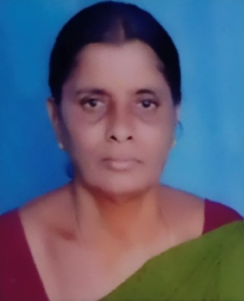
DEPARTMENT OF HOME SCIENCE
Details of Non Teaching Staff

